**University of Engineering and Management, Kolkata**

**NEWTOWN, RAJARHAT**



**Database Management System LABORATORY**

**NAME : Shubham Dutta**

**CLASS : CS-2B**

**YEAR : 2ND YEAR**

**SEMESTER : 4th SEMESTER**

**SECTION : 2B**

**ROLL NO. : 58**

**ENROLLMENT : 12019009022112**

**ASSINGMENT-3**

1. **Display the employee name from the table Employee whose salary is in the range of 2500,5000.**

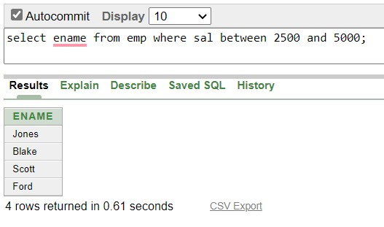

1. **Display the employee name whose salary is in the range of 2500, 4500 and do not show employee name with a employee id 7788, 7839.**

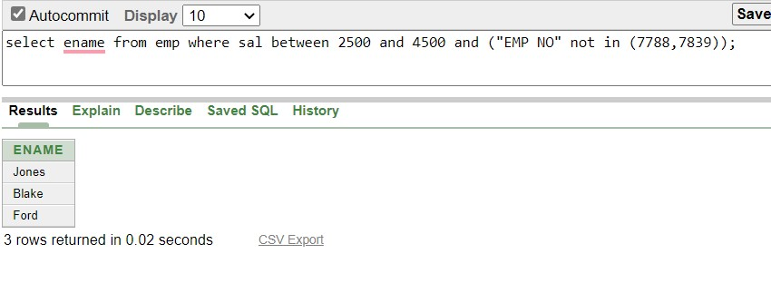

1. **Display the employee name whose salary is not in the range of 2500, 5000.**

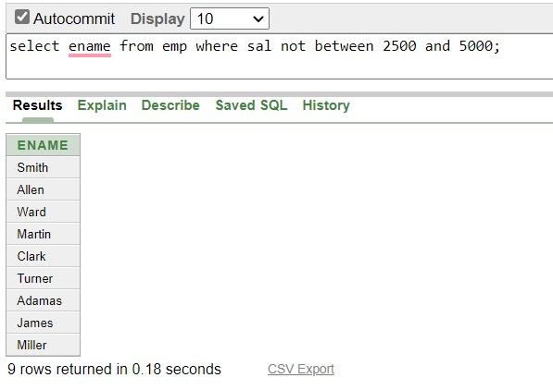

1. **Find the minimum salary from the table employee.**

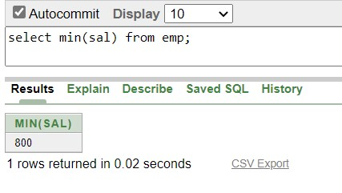

1. **Find the maximum salary from the table employee.**

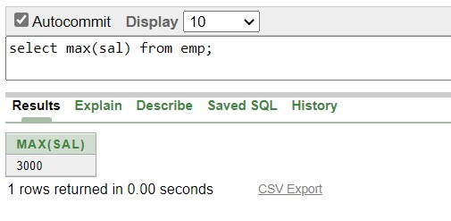

1. **Find average salary from the table employee**

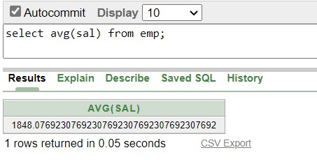

1. **Find sum of the salary from the table employee.**

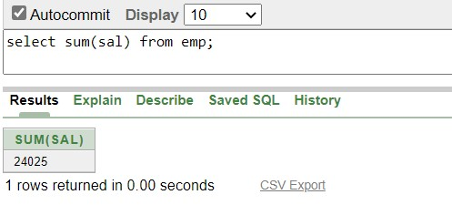

1. **Count commission from table employee.**

